8.1. Data Flow Diagram Level-2: Patient & Test Request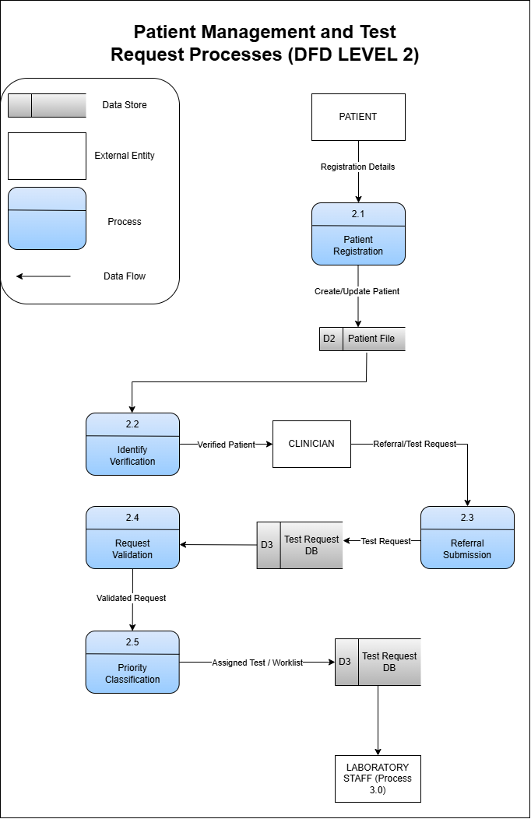
Figure 1. DFD Level 2: Patient Management and Test Request Processes
External Entities
- Patient
- Clinician
Data Stores
- D2 – Patient File
- D3 – Test Request Database
Processes
 | Input | Process | Output | Data Store
2.1 Patient Registration | Registration details (Patient) | Register a new patient or retrieve an existing patient record | Patient profile | Read/Write -> D2 Patient File
2.2 Identify Verification | Patient ID  Patient profile | Verify patient identity and eligibility using the Patient File | Verified patient identity | Read -> D2 Patient File
2.3 Referral Submission | Referral information  Test request (Clinician) | Receive and record the clinician’s referral and requested laboratory tests | Submitted test request | Write -> D3 Test Request Database
2.4 Request Validation | Submitted test request  Verified patient identity | Validate: patient identity, referral completeness, required information, and requested tests | Validated request
2.5 Priority Classification | Validated request | Determine request priority: routine, urgent, and emergency | Assigned Test /Worklist | Update -> D3 Test Request Database

- Laboratory Staff (Process 3.0)

